- Show the Table Created.
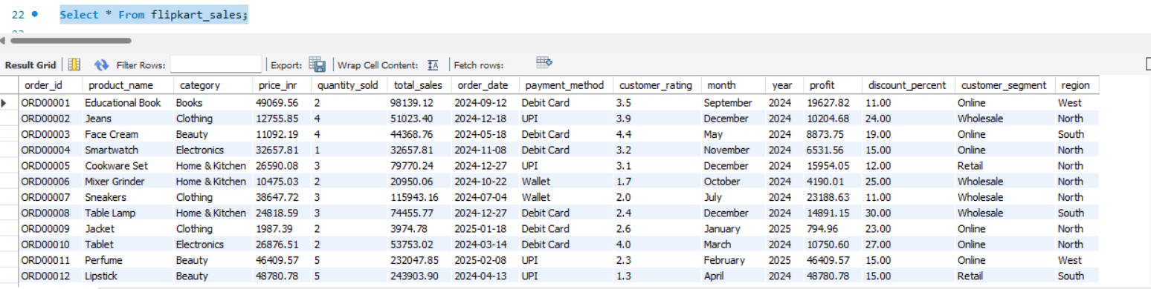

- Check table structure.
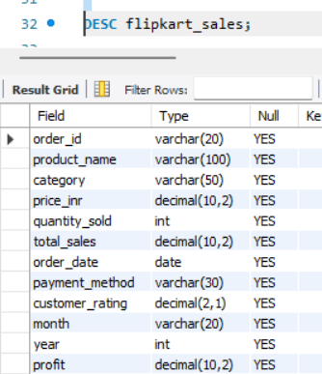
Insight: Understand schema before analysis.
- Check null values
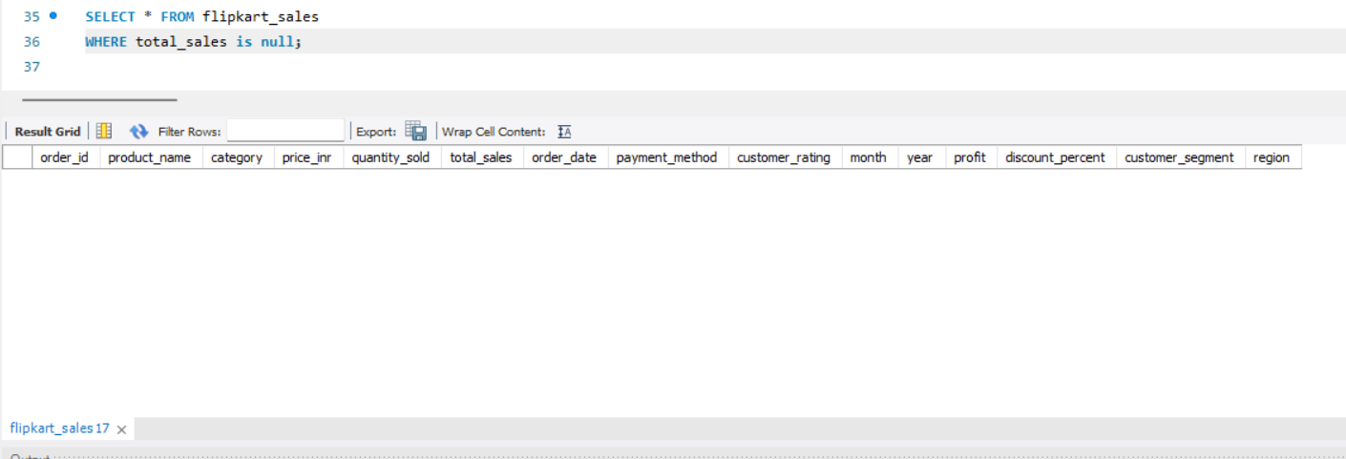
Insight: Missing values reduce accuracy.
4) Check duplicate orders.
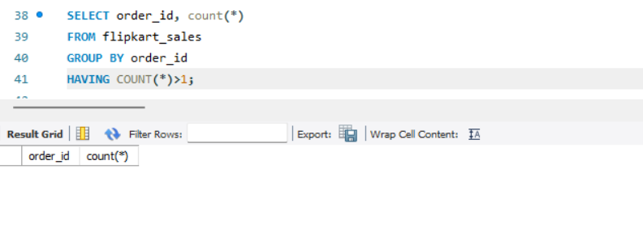
Insight: Duplicates can inflate sales.
5) Check invalid sales values.
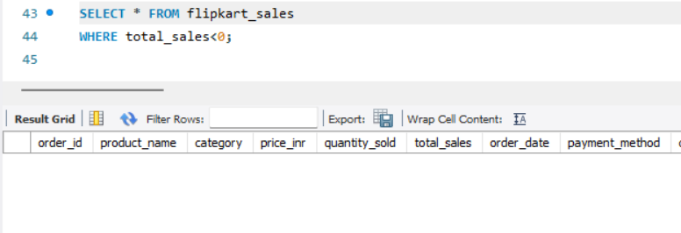
Insight: invalid records must be removed.
6) Standardize region values.
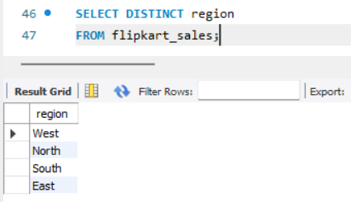
Insight: Prevent SOUTH/south duplication.
7) Total revenue.
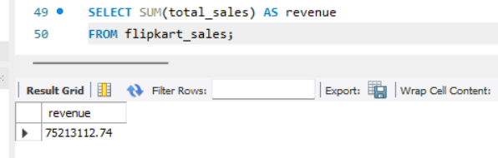
Insight: Overall business performance.
8) Average order value.
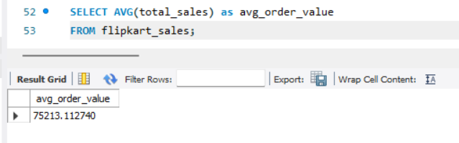
Insight: Average spending per order.
9) Highest revenue product.
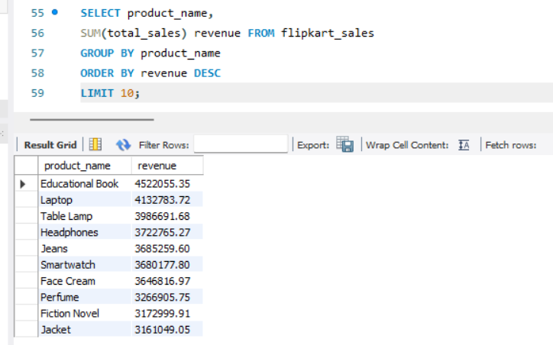
Insight: Top earning products.
10) Revenue by Category.
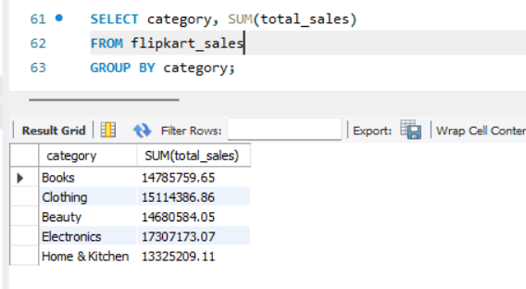
Insight: Best performing category.
11) Revenue by month.
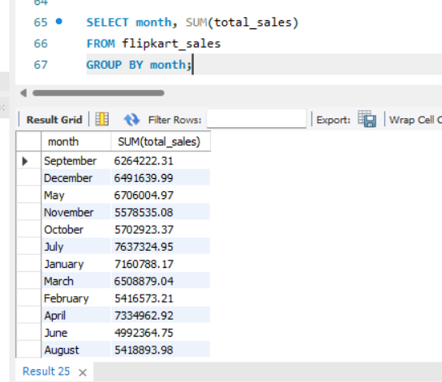
Insight: Seasonal demand trend.
12) Revenue by year.
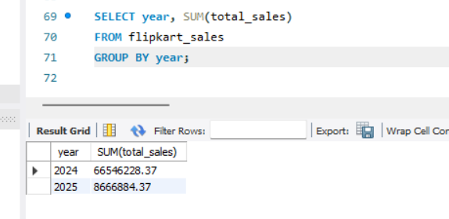
Insight: Growth over time.
13) Top selling products.
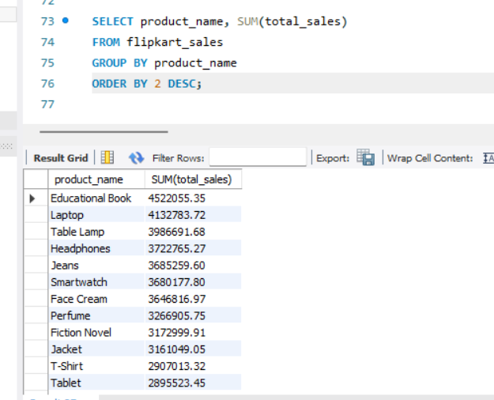
Insight: Most demanded products.
14) Top selling product by quantity sold.
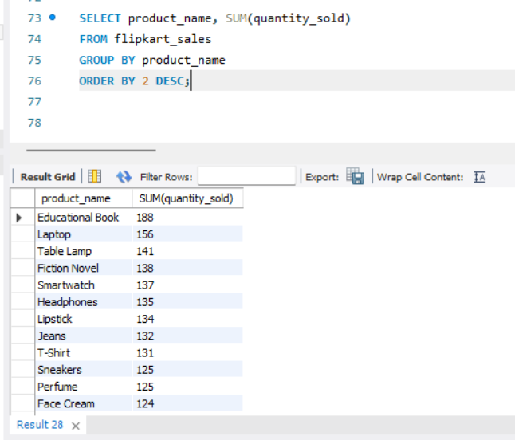
Insight: high demanding product by quantity
15) Least quantity sold by product.
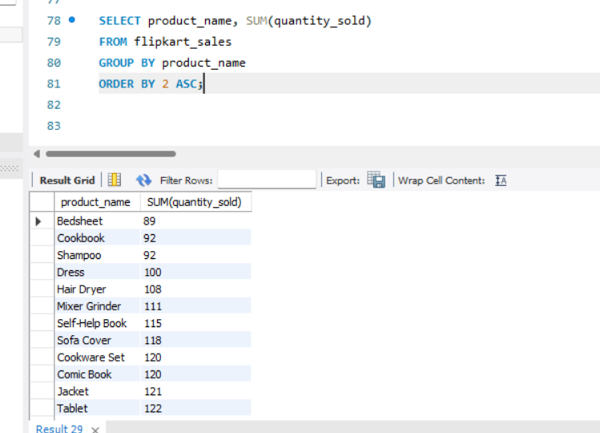
Insight: low demand by product
16) Most profitable product.
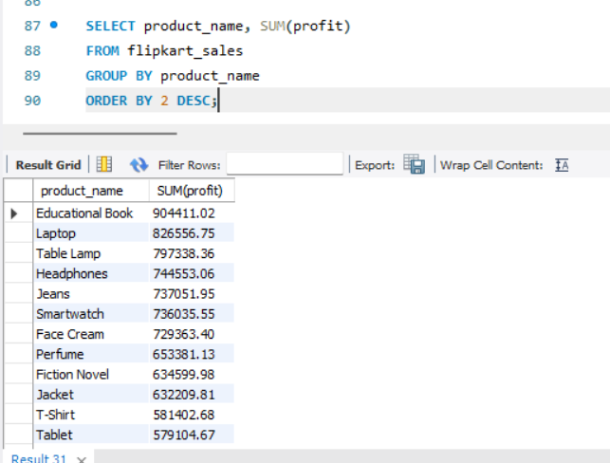
Insight: Most profit contributors.
17) Product rating analysis.
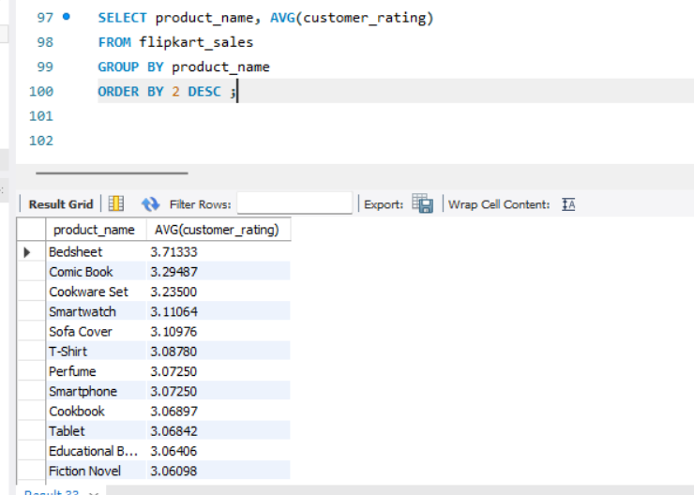
Insight: Customer satisfaction by product.
18) Product with low rating.
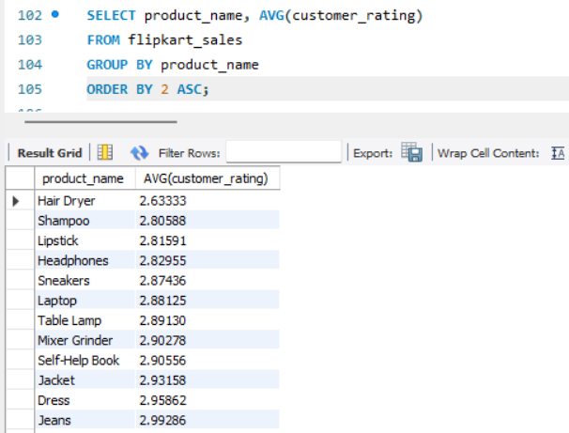
Insight: Products need improvement.
19) Total profit.
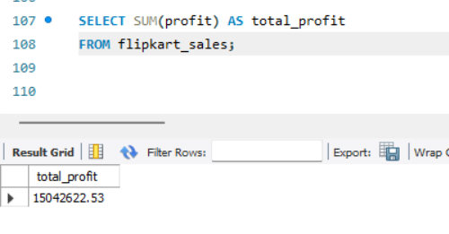
Insight: Overall profit.
20) Profit by category.
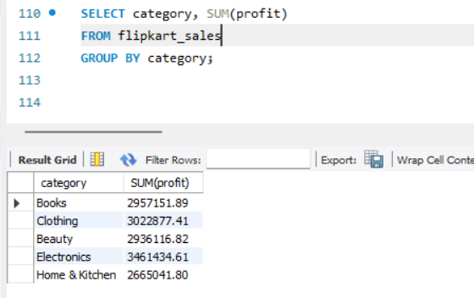
21) Profit by margin %.
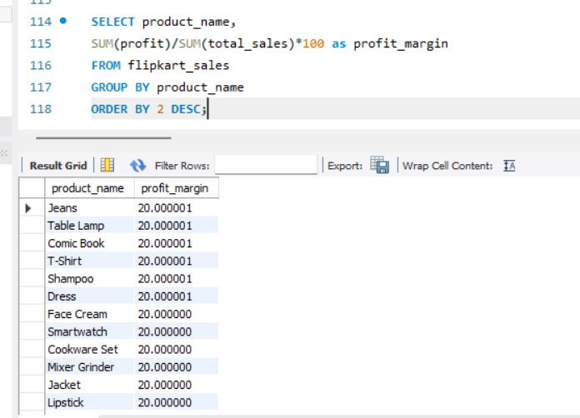
Insight: Margin efficiency.
22) Low profit products.
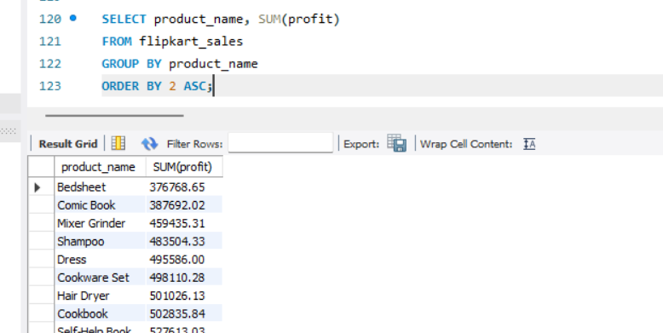
Insight: Poor performing products
23) Monthly profit trends.
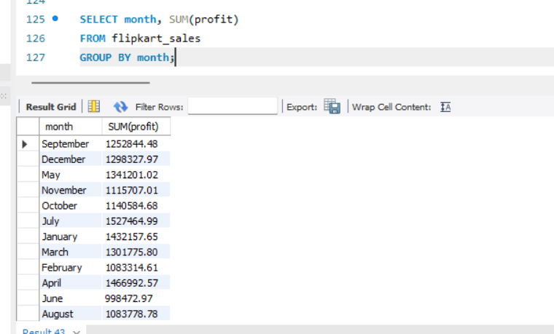
Insight: Monthly profitability changes.
24) Customer segment revenue.
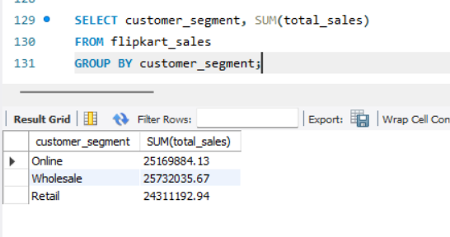
Insight: Best customer group.
25) Average customer rating.
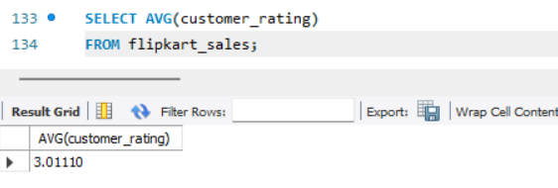
Insight: Overall satisfaction.
26) High rating products.
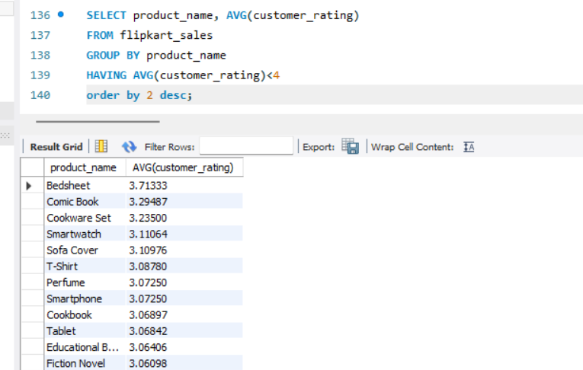
Insight: Strong products.
27) Orders by customer segment.
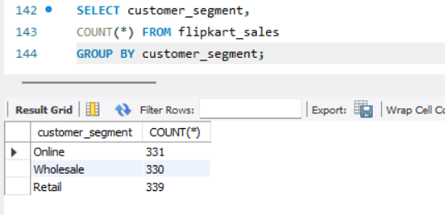
Insight: Customer distribution.
28) Region wise sales.
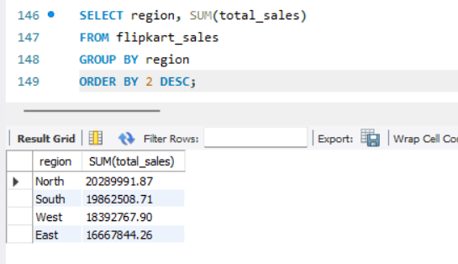
Insight: Strong region.
29) Region wise profit.
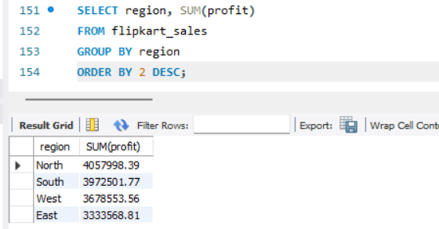
Insight: Most profitable market.
30) Payment method analysis.
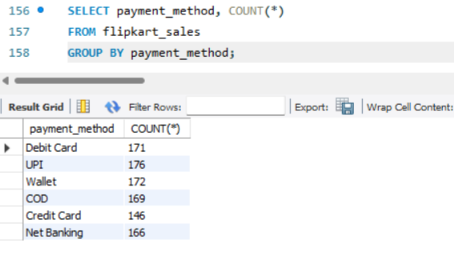
Insight: Payment preference
31) Discount impact on sales.
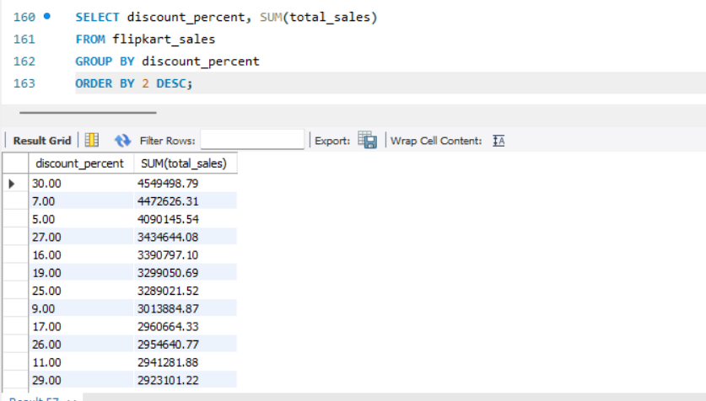
Insight: Higher discount may increase revenue but reduce profit.
32) Rank products by sales
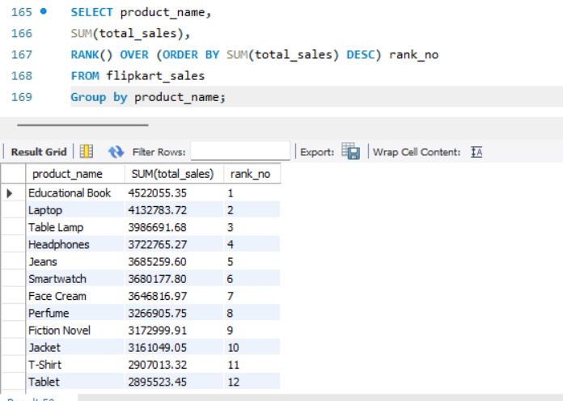
Insight: High sales ranking by product.
33) Running total sales
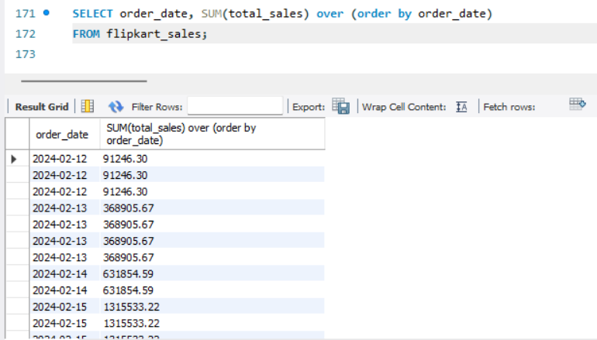
34) Revenue contribution %.
